CHEMICAL ENGINEERING TRANSACTIONS  VOL. 91, 2022 | A publication of
The Italian Association
of Chemical Engineering
Online at www.cetjournal.it

Guest Editors: Valerio Cozzani, Bruno Fabiano, Genserik Reniers
Copyright © 2022, AIDIC Servizi S.r.l.
ISBN 978-88-95608-89-1; ISSN 2283-9216

Application of quality, safety and environmental management tools in industrial companies from the litographic sector
Jeniffer Gracia^{a*}, Paola Acevedo^{b}, Emiro Trujillo^{ab}
ªUniversidad Distrital "Francisco José de Caldas", Bogotá, Carrera 7 No. 40B-53, Colombia
^{b}Department of Industrial Engineering, Universidad Cooperativa de Colombia, Bogotá, Avenida Caracas 37-63, Colombia
jpgraciar@udistrital.edu.co

This research contains a study performed in different companies from the lithographic sector of Bogotá city, Puente Aranda neighborhood. Currently, these companies require high consumption of raw materials and chemical substances to manufacture books, magazines, manuals, posters, brochures, and others. As a result, they lead to wasted paper, inks, glues, and solvents derived from different processes, generating various environmental impacts and occupational diseases.
To contribute to these companies' Industrial Safety and Occupational Health and environmental management and identify their environmental impacts, quality management tools and search for solutions were applied to the analysis of processes and products. It allowed the collection of relevant information on resource consumption, waste production (quantity and type of waste) and final disposal, and emissions at the source, heading to identifying the critical points to determine improvement opportunities.
According to the results obtained, approximately 21.33 Kg of toxic waste is generated monthly as hazardous waste or wastes during the manufacturing process. It causes different environmental impacts such as atmospheric toxic emissions and contamination of water sources, of which 56% corresponds to the waste and discharges through the production area; these discharges correspond to toxic wastes such as inks, glues, and reagents, which have special handling for this type of companies.

Key words: cleaner production, hazardous waste, lithographic sector.
  - Introduction
The lithographic sector contributes a significant portion to the industrial consolidation in Colombia. For this reason, it is crucial to evaluate the environmental impacts that this sector generates. According to IHOBE (2000), the main environmental issues detected in the lithographic sector are inks, hazardous residues generation, excessive use of paper, and a high percentage of maculature, around 90% of the total residues generated in all the lithographic companies. The lithographic companies located in Bogotá present high quantities of raw materials used and high use of chemicals during the manufacturing of books, magazines, manuals, posters, and publicity. Additionally, this manufacturing process generates high amounts of residues. According to a study made by “Cámara de Comercio de Bogotá” (CCB), the graphic arts sector represents 2.61% of the GDP. Therefore, the sector generates negative environmental impacts to cover the city's great demand. Furthermore, there is no management plan for the disposition of the residues after products at the end of life.

On the other hand, through the cleaner production strategy applied in the graphic arts industries, it is possible to reduce emissions that generate diseases, reduce water consumption and effluent discharges, improve energy efficiency by making the processes more sustainable. In addition, to obtaining economic and competitive advantages and generating employment through diversification, technological modernization, and innovation, they have achieved sustainable economic growth (Aristizábal, Avendaño, and Ruiz, 2016). Furthermore, preventing and efficiently minimizing the impacts and risks to occupational health, safety, and the environment resulting from industry guarantees environmental protection. It allows an approach to responsible management in corporate development (Minambiente, 2021). All these goals can be achieved by reducing the consumption of raw materials and improving processes to be environmentally friendly. Moreover, considering the acquisition of raw materials to their final disposal reduces waste and improves the responsiveness of the productive sectors to market demands (Fajardo, 2017).

Environmental Management Systems are crucial in explaining environmental improvements and company performance. Thus, some authors assume that thanks to the implementation of such systems, enterprises can (Amores, J., et.al., 2015; Bugdol, et. al., 2020):
- Improve the corporate image and reputation.
- Fit environmental regulations
- Strengthening in the market
- Obtain competitive advantages
- Cost reduction and improvements in operational performance and quality of production.

All these items represent an environmentally friendly behavior at the microeconomic level, as it plays a considerably positive role in such management processes.

Adopting ISO management standards relates directly to efficient applications that improve internal practices based on recognized management principles to establish social legitimacy and respond to specific external pressures. In this context, life cycle analysis must define the significant environmental aspects that will impact the operational plan and subsequent controls. Whether the objective is to improve customer satisfaction, measure and reduce emissions, increase productivity in a company or implement a policy (Boiral, O., 2011), this is important since, according to Belantová and Peterek (2020), the risk management process gives businesses a competitive advantage.

In this sense, the graphic arts industries in Bogotá D.C. are committed to creating integrated quality management systems, which seek to implement occupational health and safety management, environmental management, compliance with legislation, and the application of good labor and environmental practices.

Therefore, this research contributed to promoting in the companies of the lithographic sector of Bogotá D.C. training in the organization, the identification of environmental aspects and impacts, the implementation of corrective actions, as well as in the formulation, implementation, and maintenance of the ISO 14001-2015 standard, in order to achieve optimal environmental performance (Ramírez, 2013), and following the twelfth objective of sustainable development, responsible production and consumption. Furthermore, the above could be integrated into companies with the advances in quality management ISO 9001 and management systems for occupational health and safety at work ISO 45001. Therefore, with this contribution, it is relevant to recognize the relationship between integrated management systems, improved occupational health and safety, and cleaner production in companies in the graphic arts sector, applying quality tools.
  - Materials and methods
The research was developed in three main stages: diagnosis, analysis, and proposal formulation. First, based on the information collected in the graphic arts companies, the production processes carried out were detailed, which allowed us to know in detail their activities, consumption, and impacts, following the methodology of Bastidas, et. al.

Then, verifying the information collected in the companies was the next step. The information analysis step includes quantitative and qualitative environmental diagnostic tools such as the flow diagram, the Ecobalance, the MED Matrix, and environmental aspects and impacts analysis. Finally, the quality tool Failure Mode and Effects Analysis (FMEA) was applied, considering that failure modes are those elements that do not meet the specifications and that can potentially fail within a system, and the effects are the symptoms perceived by the customer.

Usually, referring to the system's performance, the methodology of Camisón, et al., 2006; Gutiérrez and Vara, 2013 allows to know the root causes of failures in environmental management and industrial safety to propose adequate controls (Lópes, et. al., 2013).

  - Results and Analysis
The study used cleaner production tools to process products in two graphic arts companies as a diagnostic strategy. The goal was to identify the environmental and health impacts on workers generated in companies in this sector by using raw materials such as paper, inks, glues solvents, and alcohols.
3.1 MED Matrix
All environmental impacts were integrated from start to finish of the production process in a plotter printing press, involving procedures, activities, and materials used, and in Table 1, the stages are detailed, relating them to inputs and wastes.
Table 1: MED Industries Matrix Lithographic Sector
 | MATERIALS | ENERGY | WASTE
RAW MATERIAL | Inks: QUICKSON series, TOUGH-TEX series, DAY- GLO series, offset paper, coated paper, grammage (brochures and magazines) transparent acetate films.  Digital material, lithographic cleaner, aluminum plates, rubber threads, polypropylene, paper inks, glues, solvents, alcohols. | Electricity Fossil  Fuels | Cardboard boxes.  Cardboard rolls.  Solids contaminated with inks.
PRODUCTION | Direct printing, blanket printing, water-based printing, screen printing, pre-printing: photocomposition, printing: plates, post-printing: cutting, folding, milling, stitching, binding, packaging. Pre-press, converting, cutting white paper, printing, cutting printed paper, laminating, folding, sewing, gumming, coating, cardboard cutting, hardcover assembly, wire drawing. | Electricity | Discharges of polluted water, wastewater from development, solid and leftover waste, waste ink, batteries, toner and acetate waste, fluorescent bulbs, digital and technological waste, reagents, glues and wet solids, ultra violet lights.
DISTRIBUTION | Forklift trucks, overland transport, packaging and warehousing. | Fuel | Combustion gases, leftover bags and damaged boxes.
USE | Advertising, printing of books, magazines, brochures.  Cleaning of equipment, cleaning of printing plates, dies. | Electricity | Hazardous liquid and solid waste.
END OF LIFE | Internal management of usable, ordinary and hazardous waste together with external managers. | Electricity | Final waste disposal, incineration of solid waste, liquid waste.
3.2 Flow chart
The companies studied have a logical flow diagram appropriate to the process. However, they do not have time or decision-making arrangements, and waste and emissions are not included in the process. For example, figure 1 shows the flow diagram of a graphic arts company.
3.3 Eco balance
Energy consumption is essential for these companies. Therefore, their maximum cost lies in this, as the machinery and equipment use energy to carry out their production process. Figure 2 shows the general Eco balance of the production process in the lithographic industries studied.
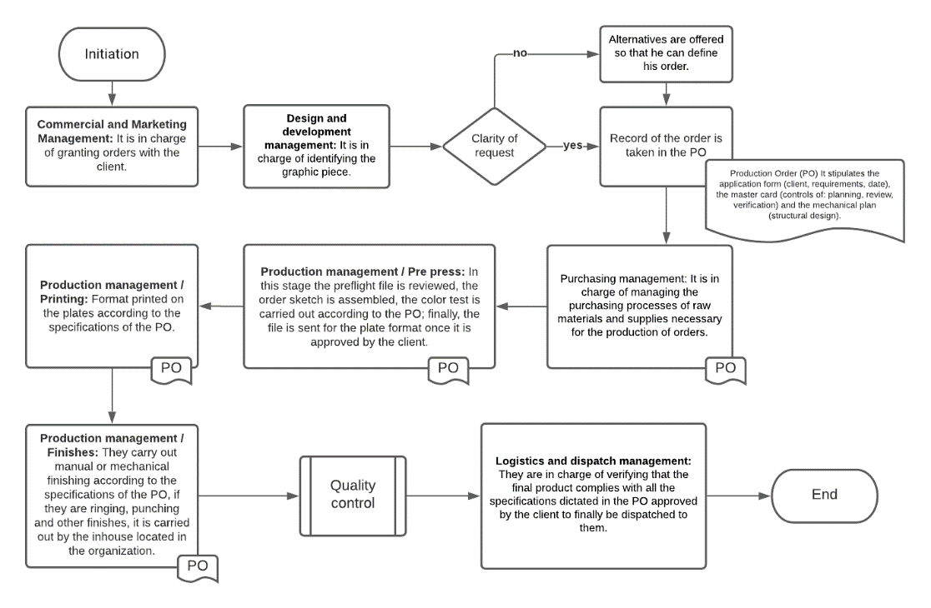

Figure 1: Flow chart of a lithographic industry company
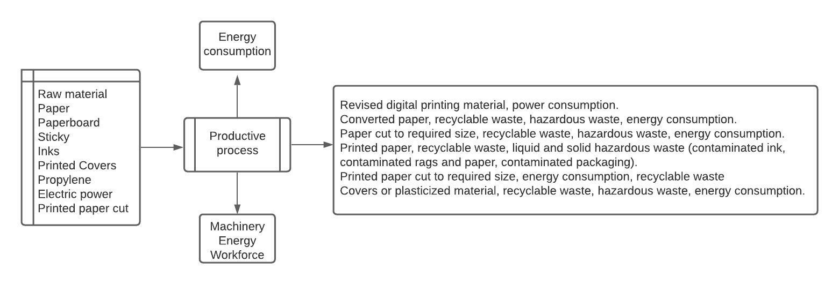
Figure 2: Ecobalance sheet lithographic sector company
3.4 Assessment of the environmental impacts of companies in the Lithographic sector
At this stage, we used the methodology promoted by the District Secretary of the Environment of Bogotá D.C., which relates frequency, probability, quantity, hazardousness, scope, reversibility, public sensitivity, applicable legislation, and severity to determine the prioritization ranges of environmental impacts. Figure 3 summarizes the results found for the identified environmental aspects. Histogram colors indicate: Red: highly significant, Blue: moderately significant, Green: 11% low significance.

Figure 3: Environmental Impact Assessment of the lithographic sector

The hazardous liquid waste, like metals, inks, wastewater mixed with chemicals, alcohols, fixatives, hazardous solid waste, atmospheric emissions, and energy consumption, is the most significant environmental impacts according to the assessment carried out, within the medium range of impact are used film waste, liquid and solid waste (mixed), packaging, recyclable waste, dirty rags, and used plates, books, diaries, calendars, posters, noise generation. In 16 environmental aspects assessed, 46% are highly significant, 43% are moderately significant, and 11% are of low significance.
3.5 Quality tool Failure Mode and Effect Analysis (FMEA)
FMEA is a widely used tool in planning, as it is a systematic method that allows the evaluation of deficiencies derived from the inadequate operation of a service, assessing the processes, and identifying where they could fail and thus estimating their impact, to determine the parts of the process that must be modified to prevent errors that generate more significant problems. (Vasquez et al., 2017)

Figure 4: FMEA Matrix Histogram

Considering that through the FMEA, it is possible to achieve an integral perspective of the process, the application of this tool promotes continuous quality improvement as it allows the identification of the parts of the process in which failures are being committed to analyzing their causes in searching alternatives for improvement implementation (Rojas, 2019). Furthermore, the above uses staff capacity and active participation, and the accurate collection of information (García, 2015).

Figure 4 summarizes the FMEA matrix performed; a quality tool applied to the environmental aspect in one of the lithographic companies analyzed. The analysis consists of grouping the sum of the Risk Priority Levels - RPL for each effect, considering the calculations of failure modes and the probability of occurrence, the severity of the failure, and the non-detection probability.

Finally, using the results, it was possible to propose measures to control failures and effects. The first measure suggested were:
- The use of biodegradable solvents.
- Energy and water-saving due to efficient use programs.
- Solid waste management program.
- Circular economy.
- Implementing a wastewater treatment plant.
- Installation of the rainwater collection system.
- Replacing raw materials with eco-friendly ones.
- Using personal protective equipment.
- Carrying out corrective maintenance on machines to control noise.

4. Conclusions
During the manufacturing process of the products, approximately 21.33 kg of toxic waste is generated monthly.
Hazardous waste generates different environmental impacts such as toxic atmospheric emissions and contamination of water sources. As well as health effects on workers by inhalation of toxic gases, it was also estimated a high consumption of electrical energy monthly, on average of 1.002.467 kW per hour, a generation of ordinary solid waste of around 6.29 kg per month, and a generation of recyclable solid waste of 1.049.943 kg per year, the annual water consumption is 1.124m³.
In contrast to the guide of the Bogota district environmental secretary for the integrated management and handling of waste for the printing and lithography industries are classified as small waste generators. However, they must have controlled methods and established standards, as the study showed that there are still regulatory requirements to be met. Furthermore, the control methods required make it more challenging to achieve the environmental goals because the processes of the lithographic companies do not allow for the complete identification of environmental performance. Therefore, environmental management plans were formulated for the significant environmental aspects that alter environmental sustainability and the health of workers, in the components of air, soil, and water; it was also recommended the generation of new designs of production processes to make them more eco-efficient, eco-friendly, healthy and safe.
Acknowledgments
Participating companies from the graphic arts sector in Bogotá.
References
Amores J., Martin de Castro G., Navas J., 2015, The importance of the complementarity between environmental management systems and environmental innovation capabilities: A firm level approach to environmental and business performance benefits. Technological Forecasting and Social Change, 96, 288-297.
Aristizabal K., Avendaño Y., Ruiz L., 2016, Cleaner production as an innovative strategy applied in a company in the textile sector. Free University, <https://hemeroteca.unad.edu.co/index.php/riaa/article/view/2271/2504> accessed 24.10.2021.
Bastidas U., Casanova M., Deyby M., Gomez J., 2021, Implementation criteria ISO 14001:2015 Case Study Management and Treatment of RESPEL.
Belantová T., Peterek K., 2020, Access of SMEs to the Risk Management Process, Chemical Engineering Transactions, 82, 37-42.
Boiral O., 2011, Managing with ISO Systems: Lessons from Practice. Long Range Planning, 44,3, 197-220.
Bugdol M., Puciato D., Borys T., Jagellonica U., 2020, Environmental management systems in the context of sustainable development: identifying open problems Systemy zarządzania środowiskiemw kontekście zrównowa- żonego rozwoju - identyfikacja otwartych problemów. 15,2, 131-142.
Cámara de Comercio de Bogotá, 2021, View of cleaner production as an environmental strategy in the framework of sustainable development. <http://ojs.urepublicana.edu.co/index.php/ingenieria/article/view/395/348> accessed 12.8.2021.
Camisón C., Cruz S., 2006, Quality management: concepts, approaches, models and systems, Ed. Pearson Education.
Fajardo H., 2017, Cleaner production as an environmental strategy in the framework of sustainable development, Journal of engineering mathematics and information sciences, 4,8,47-59.
García J., 2015, Improving the design of a service using the AMFE methodology. An application in a hotel company, Universidad Politécnica de Cartagena.
Gutiérrez P., De la Vara S., 2013, Statistical quality control and Six Sigma, Ed. McGraw Hill.
Gracia J., Cepeda J., Lopez L., Acevedo P., 2018, Application of Cleaner Production for Environmental Management in Mezcauchos SAS, Chemical Engineering Transactions, 67, 427-432.
Hoof B., Monroy N., Saer A., 2008, Cleaner production paradigm of environmental management, Ed. Alfaomega.
IHOBE, 2000, White Paper on Waste and Emissions Minimisation, Sociedad Publica Gestión Ambiental, Spain.
Lopes A., Delai I., De Castro A., Ometto R., 2013, Quality tools applied to Cleaner Production programs: A first approach toward a new methodology, Journal of Cleaner Production, 47, 174-187.
Minambiente, 2021, Sustainable production and consumption. <https://www.minambiente.gov.co/index.php/component/content/article/154-plantillaasuntos-ambientales-y-sectorial-y-urbana-7> accessed 14.7.2021.
Ramirez L., 2013, State of the art on the impact of environmental management system based on ISO 14001 on the sustainability of organizations, Journal of Chemical Information and Modeling, 53(9), 1689-1699.
Rojas S., 2019, Implementation of failure mode and effects analysis (FMEA), Glosas de Innovación Aplicadas a La Pyme, 8, 64-75.
Vásquez K., Rodríguez D., Andrade J., Valderrama L., 2017, Modal analysis of failures and effects (AMFE) in the provision of two services of the I.P.S neurotrauma center, Universidad de Santander UDES.

